
Personal Finance Tracker Using Java:
A Desktop-Based Budget Management System
A CAPSTONE PROJECT REPORT
A Capstone Project Report submitted in partial fulfilment of the requirements for the Course of
CSA0915 – Programming in Java
to the award of the degree of
BACHELOR OF TECHNOLOGY
IN
Information Technology
Submitted by
S.R Chaitra (192421425)
M.Abi shree (192424405)
Rhema Daphne E G (192321097)
Under the Supervision of
Dr. Meganathan E
SIMATS ENGINEERING
Saveetha Institute of Medical and Technical Sciences
Chennai-602105
SEPTEMBER 2026
BONAFIDE CERTIFICATE
This is to certify that the Capstone Project entitled "Personal Finance Tracker Using Java: A Desktop-Based Budget Management System" has been carried out by S.R Chaitra (192421425), M.Abi shree (192424405), Rhema Daphne E G (192321097) under the supervision of Dr. Meganathan E and is submitted in partial fulfilment of the requirements for the current semester of the B.Tech Information Technology program at Saveetha Institute of Medical and Technical Sciences, Chennai.

COURSE COORDINATOR
COURSE FACULTY
Dr. Meganathan E, Professor,
Programming in Java, SIMATS Engineering,
SIMATS, Chennai – 602105.

Dr. G. Charlyn Pushpa Latha, Professor,
Programming in Java, SIMATS Engineering,
SIMATS, Chennai – 602105.

DECLARATION
We, S.R Chaitra (192421425), M.Abi shree (192424405), Rhema Daphne E G (192321097) of Information Technology, SIMATS Engineering, Saveetha Institute of Medical and Technical Sciences, Chennai, hereby declare that the Capstone Project Work entitled "Personal Finance Tracker Using Java: A Desktop-Based Budget Management System" is the result of our own bonafide efforts. To the best of our knowledge, the work presented herein is original, accurate, and has been carried out in accordance with the principles of engineering ethics and academic integrity. All sources, references, data, and other materials used in the project have been appropriately acknowledged. We further declare that the data, results, analysis, and findings presented in this report have not been fabricated, falsified, or manipulated. Any external tools, software, datasets, computational resources, or AI-assisted tools used during the project have been appropriately disclosed. We confirm that all applicable ethical, academic, institutional, and professional requirements have been duly followed throughout the planning, execution, analysis, and documentation of the project.
Place: Chennai
Date: 04/09/2026
Signature of the Students with Names
Individual Contribution Statement
Student Name / Register No. | Specific Responsibilities | Design & Development Contribution | Testing & Analysis Contribution | Report Contribution | Approx. Contribution (%)
S.R Chaitra (192421425) | Module 2 – Smart Budget & Financial Planning | Designed budget monitoring logic & smart reallocation engine | Tested budget threshold alerts & reallocation accuracy | Existing & Proposed System, Module 2 write-up | 33.3%
M.Abi shree (192424405) | Module 3 – Analytics, Goals & Alerts | Designed Financial Health Score logic & prediction module | Tested anomaly detection & alert notifications | Module 3 write-up, Conclusion | 33.3%
Rhema Daphne E G (192321097) | Module 1 – User & Transaction Management | Designed user authentication & transaction handling | Tested transaction accuracy & balance calculation | Introduction, Problem Statement, Module 1 write-up | 33.3%
Total |  |  |  |  | 100%
ABSTRACT
Managing personal finances manually often leaves individuals unaware of when a spending category is approaching or exceeding its limit. Overspending in one category can silently disturb the planned allocation for other essential expenses and savings, and existing basic expense trackers mostly record transactions without offering meaningful prediction, analysis, or personalized guidance. Users frequently forget recurring expenses or savings commitments, resulting in an inaccurate picture of the money actually available to them. This creates a clear need for a single system that not only records income and expenses but also monitors spending in real time, suggests corrective action, and proactively alerts users before problems arise.
This project proposes the Smart Personal Finance Assistant, a Java-based desktop application built to help users plan, track, and understand their personal finances. The system is developed through three integrated modules. Module 1 handles user registration, secure login, and transaction management, allowing users to record income and expenses with date, category, amount, payment method, and description, while automatically calculating total income, total expenses, and current balance. Module 2 implements smart budget and financial planning, enabling users to set monthly or category-wise spending limits and protected savings amounts; the module monitors spending in real time, raises warnings at predefined thresholds, and can suggest transferring unused funds between categories with user approval, supported by a “Can I Afford This?” affordability check. Module 3 delivers analytics, goals, and alerts — tracking savings goals, analyzing spending trends, predicting month-end expenses, detecting unusually high transactions, computing an explainable Financial Health Score, and sending personalized recommendations along with email and SMS notifications for critical financial events.
The system was implemented and tested using sample and live transaction data, successfully calculating accurate balances, tracking category-wise budgets, generating warning and critical alerts before and after overspending, and producing a Financial Health Score with supporting insights. The smart budget and financial planning module (Module 2) proved central to the platform, as it directly governs how effectively a user's spending stays aligned with their financial goals.
The study concludes that combining real-time transaction tracking with smart budget monitoring and explainable financial analytics offers a practical, accessible approach to reducing overspending and improving personal financial discipline, with the budgeting-and-analytics framework providing a strong foundation for extending the system toward bank-account synchronization and multi-user financial planning in future work.
Keywords: Personal Finance Management, Smart Budgeting, Financial Health Score, Java Desktop Application, Expense Tracking, Savings Goals
TABLE OF CONTENTS
Sl. No | Title | Page No
i | CERTIFICATE FROM THE SUPERVISOR | ii
ii | DECLARATION BY THE CANDIDATE | iii
iii | INDIVIDUAL CONTRIBUTION STATEMENT | iv
iv | ABSTRACT | v
v | LIST OF FIGURES | vi
vi | LIST OF TABLES | vii
1 | CHAPTER 1: Introduction | 1
2 | CHAPTER 2: Literature Review | 4
3 | CHAPTER 3: Engineering Design & Trade-offs, Sustainability, Ethics, Safety, Risk & Security | 7
4 | CHAPTER 4: Implementation, Testing & Results, Project Management | 13
5 | CHAPTER 5: Conclusion & Reflection | 18
 | References | 20
 | Appendices | 21
LIST OF FIGURES
Figure No. | Figure Name | Page No.
3.1 | Figure 3.1: Overall system architecture of the Smart Personal Finance Assistant | 9
4.1 | Figure 4.1: Dashboard showing combined net worth, Financial Health Score and category-wise spending | 14
4.2 | Figure 4.2: Module 1 – Connected bank accounts and auto-sync transaction hub | 15
4.3 | Figure 4.3: Module 2 – Monthly budget management with category-wise limits and status | 16
4.4 | Figure 4.4: Module 3 – Financial reports and spending analysis insights | 17
LIST OF TABLES
Table No. | Table Name | Page No.
1 | Comparative Analysis of Existing Literature | 5
2 | User Requirements | 7
3 | Functional & Non-Functional Requirements | 8
4 | Software Implementation & Modern Tools Used | 13
5 | Roles & Contributions | 17
CHAPTER 1
INTRODUCTION AND ENGINEERING PROBLEM
1.1 Background
Personal financial management is a challenge most individuals face daily, yet very few tools help them understand the true state of their finances beyond a simple list of transactions. People routinely earn income, pay recurring bills, spend across multiple categories, and try to save toward specific goals, but doing this tracking manually — through notebooks, spreadsheets, or memory — is time-consuming and error-prone. As monthly transactions grow in number and variety, it becomes increasingly difficult for a person to know, at any given moment, exactly how much they have spent in each category, how close they are to a budget limit, and whether an upcoming purchase is actually affordable.
Basic expense-tracking applications typically record income and expenses and present simple summaries or charts, but they stop there. They do not warn a user before a budget is about to be exceeded, do not detect unusual or risky spending, and do not translate raw transaction data into a clear, explainable picture of overall financial health. This project applies budget-monitoring logic, spending analytics, and rule-based alerting to close that gap, using a Java-based desktop application that keeps the user continuously informed and in control of their money.
1.2 Need for the Project
As personal transactions accumulate across categories such as food, transport, bills, shopping, education, entertainment, and healthcare, it becomes difficult for a user to manually judge which category is under pressure and which spending decision might disturb their overall plan. A category can silently exceed its limit while the user remains focused elsewhere, and by the time they notice, the overspending has already reduced the money available for essentials or savings.
Existing basic trackers mainly record transactions and provide limited prediction, analysis, or personalized guidance. A simple list of transactions does not reveal whether the user is on track with their savings goals, whether a recurring payment has been forgotten, or whether their current spending pattern is unusual compared to their normal behaviour. This is a critical limitation, since responsible financial planning depends as much on early warning and informed decision-making as it does on the raw record of what was spent.
There is a clear need for a smart, single system that can monitor spending continuously, evaluate budget status in real time, forecast likely month-end expenses, flag unusual transactions, and give the user a clear, explainable measure of their financial health — helping them make informed decisions instead of discovering problems only after they occur.
1.3 Problem Statement
To design and develop a Java-based Smart Personal Finance Assistant that allows users to record income, expenses, recurring payments, and savings goals in a single system; monitors category-wise budgets in real time and warns users before limits are exceeded; analyzes spending behaviour to detect unusual transactions and predict likely month-end expenses; and computes an explainable Financial Health Score with personalized recommendations, thereby helping users manage their money proactively and avoid overspending.
1.4 Project Aim
The aim of this project is to design and implement a Java-based Smart Personal Finance Assistant that unifies income, expense, budget, and savings-goal management in one desktop application, while providing real-time budget monitoring, spending analytics, and proactive alerts to help users protect their savings and stay aligned with their financial goals.
1.5 Project Objectives
- To design and develop a Java-based Smart Personal Finance Assistant for effective financial planning and monitoring.
- To enable users to record income, expenses, budgets, recurring payments, and savings goals in one system.
- To analyze spending behaviour, calculate a Financial Health Score, and provide personalized recommendations.
- To support smart budget reallocation, expense prediction, and proactive email/SMS alerts when limits are at risk or exceeded.
- To help users make informed financial decisions while protecting their savings and financial goals.
1.6 Scope
Included: User registration and secure login; recording of income and expenses with category, date, amount, and payment method; monthly and category-wise budget setting with real-time monitoring and threshold-based alerts; smart budget reallocation with user approval; savings-goal tracking with progress estimation; spending-trend analysis, expense prediction, and anomaly detection; an explainable Financial Health Score; and email/SMS notifications for critical financial events.
Excluded: Direct integration with live banking APIs for automatic transaction import in the current version; multi-user or family-level shared budgeting; and investment portfolio management or tax planning features.
Assumptions: Users enter their transactions and budgets accurately and in a timely manner; category definitions remain reasonably consistent over time; and the device running the application has a functioning internet connection for email/SMS alert delivery.
Boundary Conditions: The system is designed for a single user's personal finances at a time and treats manually entered (or synced) transactions, budgets, and savings goals as the primary data sources for all analysis and alerts.
1.7 Expected Engineering Outcome
The project is expected to deliver a functional desktop software platform comprising: (i) a user and transaction management module for secure, accurate recording of financial activity, (ii) a smart budget and financial planning module that monitors spending in real time and supports intelligent reallocation, and (iii) an analytics, goals, and alerts module that predicts expenses, detects anomalies, and computes an explainable Financial Health Score with proactive notifications. This framework can serve as a reusable model for personal finance tools, extendable toward automatic bank synchronization and multi-user financial planning in future work.
CHAPTER 2
LITERATURE REVIEW AND EXISTING SOLUTIONS
2.1 Review Method
Relevant literature was identified through peer-reviewed and recent research on machine-learning-based expense tracking, predictive analytics for personal finance, automated expense categorization, and intelligent personal finance management systems, along with documentation of the tools and frameworks used in the proposed system (Java Swing, JDBC, MySQL, Jakarta Mail, Twilio). These were reviewed to understand existing approaches to expense tracking, budget monitoring, and financial decision-support.
2.2 Review of Existing Work
Most existing personal finance applications provide basic income and expense recording with manual budget tracking and simple threshold alerts. Recent research has moved toward applying machine learning and deep learning techniques — such as LSTM-based sequence models — to predict future expenses and visualize financial trends, and toward using AI/ML and NLP for automated expense categorization and anomaly detection. Studies combining transaction tracking, budgeting, and overspending alerts demonstrate the value of a single integrated system, while broader reviews of intelligent personal finance management highlight prediction, anomaly detection, and explainable recommendations as key directions, though most stop short of a complete, usable implementation.
2.3 Comparative Analysis
Details of the Journal | Algorithm / Methodology Used | Advantages | Limitations
Smart Expense Tracking System Using Machine Learning (2023) – Focuses on tracking and predicting personal expenses. | Machine Learning and predictive analytics | Reduces manual tracking and predicts future expenses. | Requires sufficient historical financial data.
Personal Finance Manager with Predictive Analytics Using LSTM (2024) – Analyses income, expenses and future financial behaviour. | LSTM and predictive analytics | Provides expense prediction and financial trend visualization. | LSTM implementation is comparatively complex.
AI-ML Based Expense Categorization and Budgeting System (2025) – Provides automated expense categorization and personalized budgeting. | AI/ML, NLP and anomaly detection | Automates categorization and detects unusual spending. | Performance depends on data quality.
Personal Finance Agent: Tracks Expenses, Categorizes Transactions, Suggests Budgets, and Alerts Overspending (2026) – Combines transaction tracking, budgeting and alerts. | ML-based categorization, budget monitoring and rule-based alerts | Provides automatic categorization and overspending alerts. | Advanced prediction requires further development.
Machine Learning Techniques for Intelligent Personal Finance Management Systems (2026) – Reviews intelligent approaches for personal finance management. | ML, Deep Learning and Explainable AI | Covers prediction, anomaly detection and personalized recommendations. | Does not provide a complete practical implementation.
2.4 Research / Engineering Gap
Existing tools confirm what a user has spent (basic trackers) or study prediction and categorization theoretically (recent ML/LSTM research), but very few combine real-time transaction tracking, category-wise budget monitoring, spending prediction, anomaly detection, and an explainable financial health measure in a single, usable desktop application. Manual and basic trackers ignore predictive and explainable analytics entirely. ML/LSTM-based research is powerful but often complex to implement and not connected to a complete budgeting workflow. This leaves a gap for a lightweight, transparent system that combines transaction management, smart budgeting, and explainable financial analytics in one connected tool.
2.5 Proposed Contribution
This project addresses the gap by integrating transaction management, category-wise budget monitoring, and explainable financial analytics within a single Java desktop application. Unlike basic manual trackers, it automatically monitors budgets in real time and suggests smart reallocation; unlike complex ML/LSTM research prototypes, it keeps the underlying logic simple, transparent, and explainable to an everyday user; and unlike static categorization studies, it actively uses spending data to predict month-end expenses, detect anomalies, and compute a Financial Health Score, with every step — from transaction entry to budget alerts to recommendations — made visible through an interactive dashboard.
CHAPTER 3
ENGINEERING DESIGN & TRADE-OFFS, SUSTAINABILITY, ETHICS, SAFETY, RISK & SECURITY
3.1 Requirements
Stakeholder / User Requirements
Stakeholder | Requirement
End User (Individual) | A quick, automatic way to know how much has been spent, how much budget remains, and whether a purchase is affordable
Budget-Conscious Saver | Reliable tracking of savings goals with clear progress and protection from accidental overspending
Recurring-Bill Payer | Automatic reminders for recurring expenses so payments are not missed or forgotten
Financially Cautious User | Timely email/SMS alerts when a budget is at risk or has been exceeded
Student / New Learner of Personal Finance | A simple, understandable dashboard that explains financial health without requiring prior financial expertise
Functional & Non-Functional Requirements
Requirement Type | Requirement | Measurable Target
Functional | Record income and expense transactions with category, date, amount, and payment method | Transaction saved and balance updated instantly
Functional | Calculate a Financial Health Score for the user | Score computed and displayed with supporting insights
Functional | Monitor category-wise budgets and generate warnings | Alert raised before or at the point of exceeding a limit
Functional | Generate and apply a recommended budget reallocation | Reallocation reflected correctly with user approval
Non-Functional (Usability) | Dashboard understandable without prior financial training | New user can interpret results in under 5 minutes
Non-Functional (Accuracy) | Balances and scores match expected logic | Verified against manual calculation for sample transactions
Non-Functional (Performance) | Dashboard refreshes results quickly | Response time under 2 seconds
Non-Functional (Portability) | Runs without specialised/dedicated hardware | Works on any system with Java 17+ installed
3.2 Constraints & Applicable Standards
Only the constraints that genuinely apply to this project are listed below, since this is an academic-scale software project and large enterprise compliance standards were not applicable.
Standard / Practice | Requirement | How Applied in This Project
Secure Credential Handling | Safe handling of user login credentials and stored financial data | User passwords stored using secure hashing; sensitive data not exposed in plain text
REST/JDBC Data Access Principles | Clear, structured, resource-based data access between application and database | Followed while building the JDBC data-access layer for transactions, budgets, and goals
Institutional Data Handling Guidelines | Safe handling of user financial data during testing | Followed while storing transaction and budget data securely in the MySQL database
3.3 Design Specifications
Parameter | Target/Requirement | Unit | Priority
Transaction save/update time | ≤ 1 | second | High
Budget-status calculation time | < 1 | second per category | High
Authentication method | Username & hashed password | — | High
Dashboard response time | < 2 | seconds | Medium
Alert delivery accuracy | 100% event-to-notification match | — | High
Database used | MySQL | — | High
Software/tooling cost | 0 (open-source only) | ₹ / $ | Medium
3.4 Alternative Solutions & Evaluation
Alternative 1 (Manual tracking – notebook/spreadsheet): User records income and expenses in a spreadsheet and checks totals manually. Simple and free, but slow, error-prone, and offers no automatic budget warnings or predictions.
Alternative 2 (Existing basic expense-tracker apps): Tasks are tracked with simple category summaries and charts. Reliable and widely available, but does not calculate a financial health score, predict expenses, or reallocate budgets intelligently.
Alternative 3 (Proposed — Java-based Smart Personal Finance Assistant): A custom desktop system that unifies transactions, budgets, and goals; monitors spending in real time; and provides explainable analytics and proactive alerts. Free, transparent, and extendable, at the cost of needing custom development effort.
Criterion | Weight | Alt. 1: Manual/Spreadsheet | Alt. 2: Basic Tracker App | Alt. 3: Smart Finance Assistant
Performance | 20% | 2 / 5 | 4 / 5 | 5 / 5
Cost | 20% | 5 / 5 | 3 / 5 | 5 / 5
Safety | 15% | 4 / 5 | 4 / 5 | 4 / 5
Sustainability (reuse/extend) | 20% | 2 / 5 | 3 / 5 | 5 / 5
Reliability | 25% | 2 / 5 | 4 / 5 | 5 / 5
Weighted Total | 100% | 2.65 / 5 | 3.65 / 5 | 4.85 / 5
3.5 Selected Design & Detailed Design
Alternative 3 (the Java-based Smart Personal Finance Assistant) was selected. As shown in the evaluation matrix in Section 3.4, it scored highest overall (4.85/5), leading on performance, cost, sustainability/extensibility, and reliability, while matching the other alternatives on safety. This evidence-based comparison — not personal preference — is the basis for the selection.
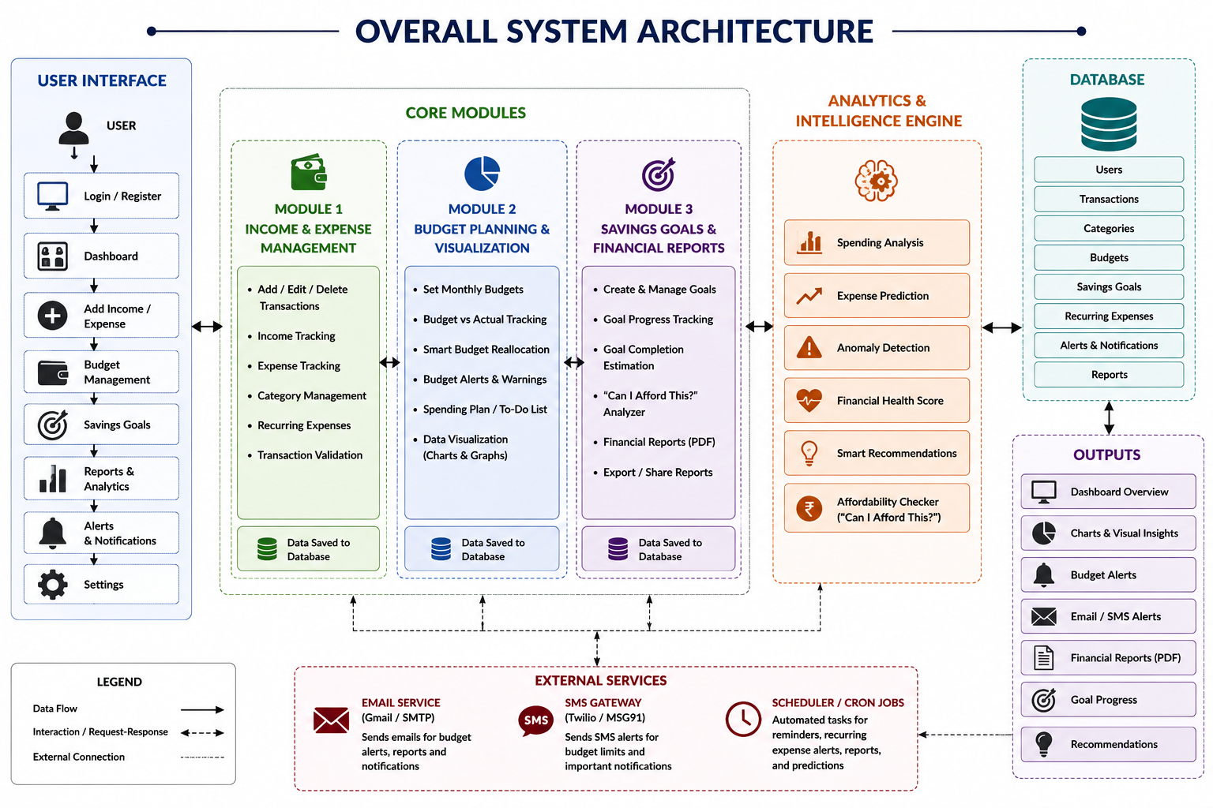
Figure 3.1: Overall system architecture of the Smart Personal Finance Assistant
Key Engineering Calculations
Financial Health Score: Score = (Savings Rate × w1) + (Budget Adherence × w2) + (Spending Consistency × w3), where each factor is weighted based on its influence on overall financial stability, and the final score is mapped to a qualitative status (e.g., Excellent, Good, Needs Attention).
Budget Utilisation: For each category, Percentage Used = (Amount Spent / Category Limit) × 100, with warning and critical thresholds triggered as this percentage approaches or exceeds 100%. Full logic is provided in Appendix A.
Systems Approach
The User & Transaction Management module (Module 1) feeds transaction data into the Smart Budget & Financial Planning module (Module 2), which monitors spending against category limits in real time. Module 2's budget-status output is consumed together with historical transaction data by the Analytics, Goals & Alerts module (Module 3) to compute predictions, detect anomalies, and generate the Financial Health Score. Recommendations and critical alerts generated by Module 3 are delivered back to the user through the dashboard and via email/SMS, while the External Services layer (email gateway, SMS gateway, and scheduler) ensures notifications are sent reliably, so all three modules reinforce rather than duplicate each other.
3.6 Trade-off Analysis
Design Decision | Alternative Considered | Benefit | Disadvantage | Final Decision & Justification
User interface framework | Web-based dashboard (HTML/JS) | Accessible from any browser | Requires a running local server; less native feel | Java Swing desktop UI chosen — simpler distribution and tighter integration with the Java backend for an academic-scale project
Data source for transactions | Direct bank API integration | Fully automatic, no manual entry | Requires bank-side approvals, security review, and ongoing API maintenance | Manual/CSV-assisted entry chosen for this version — simpler to implement reliably while still capturing accurate transaction data
Notification method | In-app notifications only | Simple to implement, no external dependency | User may miss alerts if the application is not open | Email/SMS via Jakarta Mail and Twilio chosen — ensures critical budget alerts reach the user even when the application is closed
3.7 Sustainability, Ethics, Safety, Risk & Security
Domain | Consideration | Evidence Evaluated | Impact on Final Decision
Sustainability | Minimising unnecessary notification traffic | Verified that email/SMS alerts are sent only at meaningful thresholds, not on every transaction | Threshold-based alerting selected to reduce notification overload and external service usage
Ethics | Fair and accurate representation of a user's financial status | Confirmed the same scoring logic is applied equally to every category and transaction, without bias toward any spending type | Standardised, identical scoring procedure applied uniformly to avoid misleading financial guidance
Health & Safety | Preventing financial stress from undetected overspending | Verified that the system flags at-risk budgets proactively instead of only reporting after the fact | Warning-level thresholds used to alert users before limits are fully exceeded
Security | Protection of user financial and login data | Confirmed passwords are hashed and stored securely, with no sensitive credentials in plain text | Secure authentication implemented; financial data access restricted to the authenticated user
Risk Register
Risk | Likelihood | Severity | Risk Level | Mitigation | Residual Risk
Email/SMS gateway rate limits or downtime | Medium | Medium | Medium | Implemented error handling and retry logic for notification calls | Low
Incorrect Financial Health Score affecting recommendations | Medium | High | High | Scoring logic tested against sample transaction sets before deployment | Medium
Unauthorized access to a user's stored financial data | Low | High | Medium | Secure password hashing and access control implemented | Low
CHAPTER 4
IMPLEMENTATION, TESTING & RESULTS, PROJECT MANAGEMENT
4.1 Development Approach & Resources
The project was developed using an incremental, module-wise approach. Each module — user & transaction management, smart budget & financial planning, and analytics, goals & alerts — was built and tested independently before being integrated into a single Java desktop application. This allowed errors to be caught early and let each team member develop their module in parallel.
Resource | Details
Programming language | Java 17+
UI framework | Java Swing
Database connectivity | JDBC
Database | MySQL
Notification services | Jakarta Mail (email), Twilio (SMS)
IDE | IntelliJ IDEA
Build tool | Apache Maven
4.2 Software Implementation & Modern Tools Used
Tool / Software / Library | Purpose | Stage Used
Java Swing | Build the desktop dashboard, forms, and interactive views | Module 1
JDBC + MySQL | Store and retrieve users, transactions, categories, budgets, and goals | All modules
Budget monitoring logic (Java) | Compute spent, remaining, and percentage used per category; trigger reallocation suggestions | Module 2
Jakarta Mail + Twilio | Send email and SMS alerts for budget warnings and critical financial events | Module 3
Analytics engine (Java) | Compute spending trends, expense prediction, anomaly detection, and Financial Health Score | Module 3
4.3 Test Plan & Verification
Before results were finalised, each computation was verified against an independent manual calculation, and the dashboard's responsiveness was timed.
Requirement | Test Method |  |  | Acceptance Criterion
Transactions recorded correctly | Compared dashboard totals with manually entered sample transactions |  |  | Income, expenses, and balance match exactly
Budget status is correct | Verified percentage-used and alert status against manual calculation for sample budgets |  |  | Status (Safe/Warning/Critical) matches expected value
Financial Health Score is correct | Verified score against manual calculation using savings rate, budget adherence, and spending consistency |  |  | Score and status match expected value
Alerts delivered correctly | Checked email/SMS content against triggering budget event |  |  | Notification content, category, and threshold correct
Dashboard responds quickly | Measured load/update time |  |  | Response under 2 seconds
Specification |  | Required Value | Achieved Value |  | Status
Transaction save/update time |  | ≤ 1 sec | ≈ 0.6 sec |  | Pass
Financial Health Score accuracy |  | Matches manual calc. | Matched |  | Pass
Budget alert accuracy |  | 100% event-to-alert match | 100% |  | Pass
Dashboard response time |  | < 2 sec | ≈ 1.1 sec |  | Pass
4.4 Results
The system successfully recorded income and expense transactions, calculated accurate running balances, and monitored category-wise budgets with real-time status indicators. It generated warning and critical alerts as spending approached or exceeded set limits, computed an explainable Financial Health Score with supporting insights, and produced category-wise spending breakdowns and financial reports for the user.
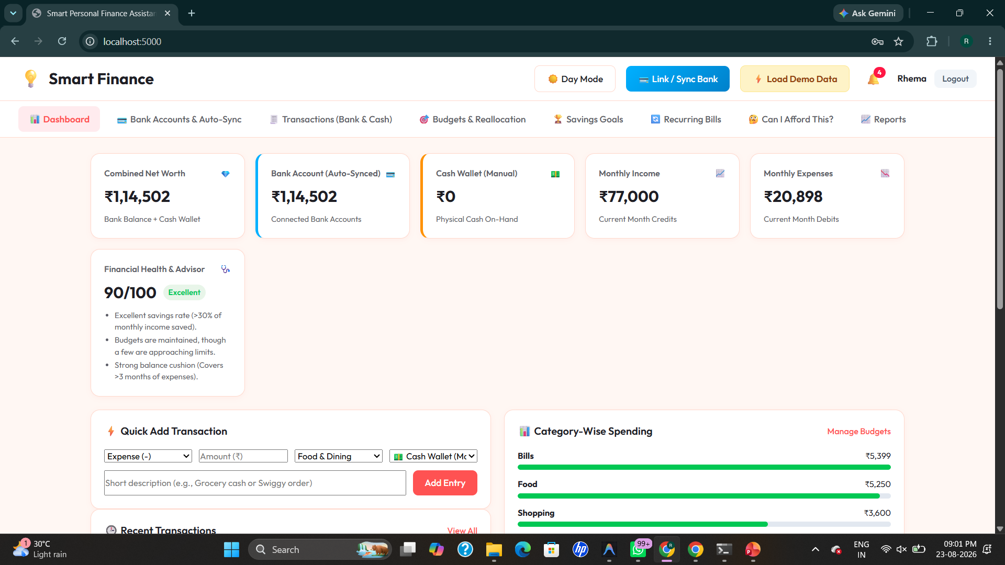
Figure 4.1: Dashboard showing combined net worth, Financial Health Score and category-wise spending
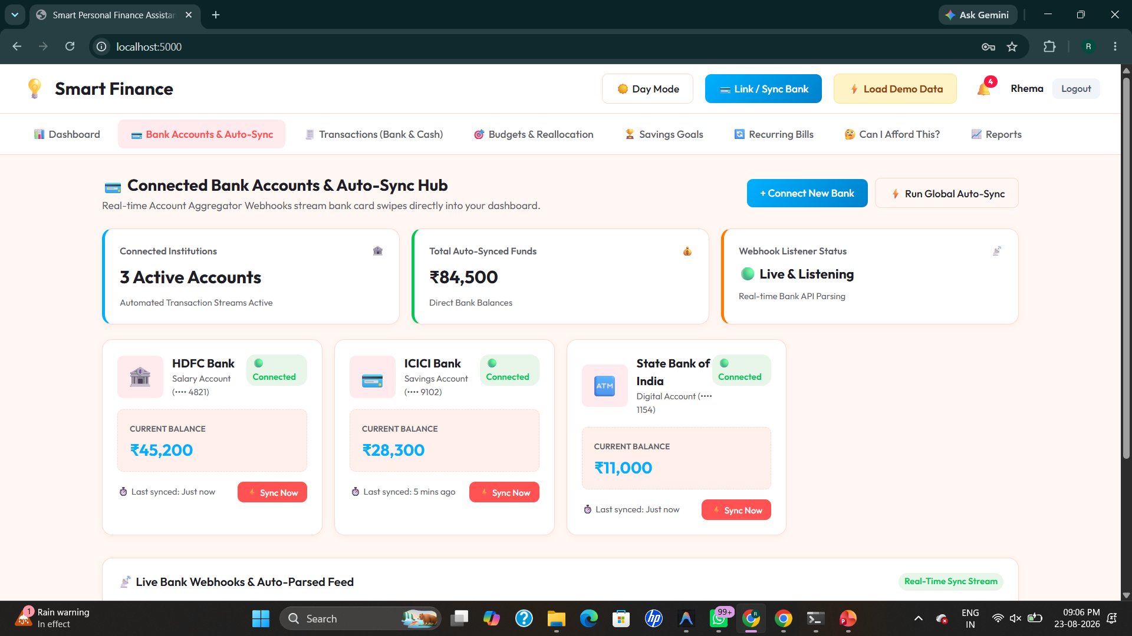
Figure 4.2: Module 1 – Connected bank accounts and auto-sync transaction hub
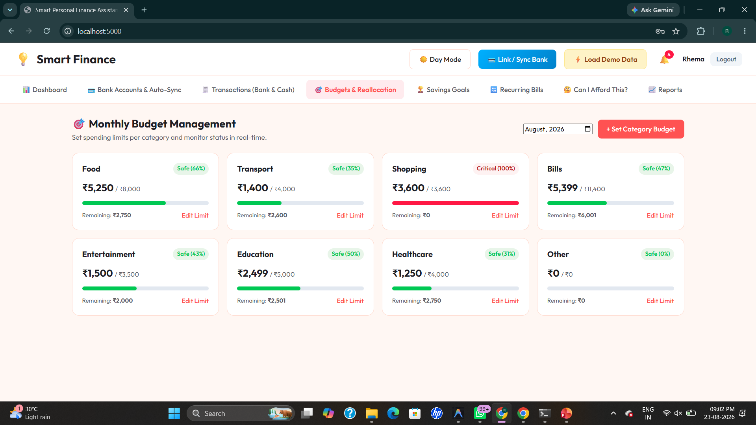
Figure 4.3: Module 2 – Monthly budget management with category-wise limits and status
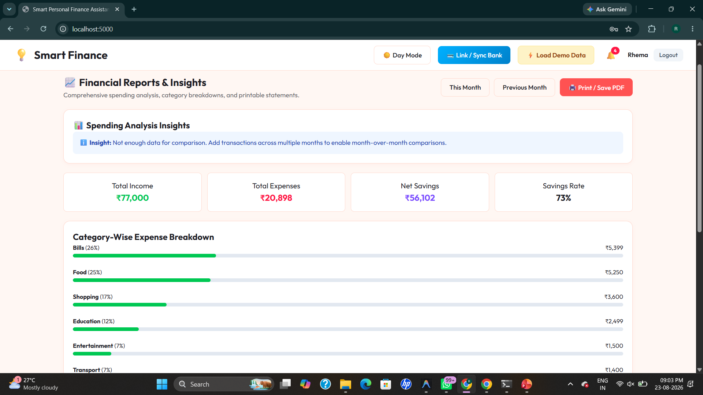
Figure 4.4: Module 3 – Financial reports and spending analysis insights
4.5 Data Analysis & Engineering Judgment
The smart budget module (Module 2) correctly flagged categories approaching or exceeding their limits, and the analytics module (Module 3) correctly translated savings rate, budget adherence, and spending consistency into an explainable Financial Health Score. This confirms that combining real-time budget monitoring with historical spending analysis gives a far more accurate financial picture than viewing raw transactions alone. A limitation observed was that prediction and scoring accuracy depend on how completely and consistently the user categorizes transactions — inconsistent categorization can distort the analysis.
4.6 Achievement of Objectives
Objective | Evidence | Achievement
Transaction management | Income, expenses, and balance recorded and calculated accurately | Fully Achieved
Smart budgeting & reallocation | Category budgets monitored in real time with reallocation suggestions | Fully Achieved
Financial Health Score & recommendations | Score computed with explainable, personalized recommendations | Fully Achieved
Prediction & anomaly detection | Month-end expense prediction and unusual-transaction detection functioning | Fully Achieved
Proactive alerts | Email/SMS notifications sent for critical budget and financial events | Fully Achieved
Usable dashboard | Response time ≈ 1.1 sec, easy to interpret | Fully Achieved
4.7 Strengths & Limitations
Strengths
- Combines transaction tracking, smart budgeting, and explainable analytics in one platform
- Real-time budget monitoring with proactive warning and critical alerts
- Explainable Financial Health Score with personalized recommendations
- Proactive email/SMS notifications for critical financial events
Limitations
- Tested on individual user accounts, not multi-user/family-scale
- Depends on consistent transaction categorization for correct scoring
- Direct live bank API synchronization not yet supported in this version
4.8 Project Planning, Roles & Budget
Milestone Timeline
Milestone | Planned Duration | Status
Literature review & requirement gathering | Week 1 | Completed
Module 1 – User & Transaction Management | Week 2–3 | Completed
Module 2 – Smart Budget & Financial Planning | Week 3–4 | Completed
Module 3 – Analytics, Goals & Alerts | Week 5 | Completed
Integration & testing | Week 6 | Completed
Report compilation | Week 7 | Completed
Roles & Contribution
Student | Assigned Responsibility | Actual Contribution
Rhema Daphne E G | Module 1 – User & Transaction Management | Designed user authentication and transaction handling; wrote Introduction, Problem Statement & Module 1 sections
S.R Chaitra | Module 2 – Smart Budget & Financial Planning | Designed budget monitoring logic and reallocation engine; wrote Existing & Proposed System, Module 2 sections
M.Abi shree | Module 3 – Analytics, Goals & Alerts | Designed Financial Health Score and prediction logic; wrote Module 3 & Conclusion sections
CHAPTER 5
CONCLUSION, FUTURE WORK AND REFLECTION
5.1 Conclusion
This project successfully designed and implemented the Smart Personal Finance Assistant, a Java-based desktop application that unifies transaction management, smart budgeting, and financial analytics. The system automatically recorded income and expenses, calculated accurate running balances, monitored category-wise budgets in real time, and generated an explainable Financial Health Score supported by personalized recommendations. Testing confirmed that the budget-monitoring logic correctly raised warnings before limits were exceeded, and the analytics engine successfully detected unusual transactions and predicted likely month-end expenses, with critical alerts delivered to the user via email and SMS. All project objectives were fully achieved, and the interactive dashboard made financial tracking and decision-making simple and transparent for the user.
5.2 Reflection
Working on this project helped the team connect classroom concepts — object-oriented programming, database connectivity, and application design — to a real, practical problem faced by individuals managing their own finances every day. Dividing the work into three modules (user & transaction management, smart budget & financial planning, and analytics, goals & alerts) allowed each member to build hands-on expertise in their area while learning to integrate individual contributions into one cohesive Java application. Key challenges included designing an accurate and explainable Financial Health Score formula, implementing reliable threshold-based budget alerts, and integrating external email/SMS services for proactive notifications. Overcoming these challenges strengthened the team's skills in Java application development, database design, and collaborative software project management.
5.3 Future Scope
- Integrate direct bank account APIs for fully automatic transaction import and reconciliation.
- Use machine learning to improve expense prediction and personalize recommendations based on long-term spending history.
- Expand the system from individual users to multi-user or family-level shared budgeting and goal tracking.
REFERENCES
- Schildt, H. (2018). Java: The Complete Reference (11th ed.). McGraw-Hill Education.
- Oracle. Java Documentation. https://docs.oracle.com/javase/
- Oracle. JDBC Basics. https://docs.oracle.com/javase/tutorial/jdbc/
- MySQL. MySQL Documentation. https://dev.mysql.com/doc/
- Tutorials Point. Java Swing Tutorial. https://www.tutorialspoint.com/swing/index.htm
- Jakarta Mail Documentation. https://jakartaee.github.io/mail-api/
- Twilio Documentation. Programmable Messaging. https://www.twilio.com/docs/messaging
APPENDICES
Appendix A – Detailed Calculations
- Financial Health Score Formula: Score = (Savings Rate × w1) + (Budget Adherence × w2) + (Spending Consistency × w3)
- Sample Score: A user with a 73% savings rate and well-maintained budgets computed a Financial Health Score of 90/100, rated “Excellent.”
- Budget Utilisation Logic: Percentage Used = (Amount Spent / Category Limit) × 100, with Warning and Critical thresholds applied per category.
Appendix B – Engineering Drawings / Schematics
- System Architecture: Flow diagram showing the User connecting to the application's User Interface, which routes through the three Core Modules into the Analytics & Intelligence Engine and the shared Database.
- Dashboard Layout: Visual representation of the application interface displaying net worth, budgets, and category-wise spending.
Appendix C – Source Code / Code Repository Information
- Development Stack: Built using Java 17+, Java Swing, JDBC, and MySQL.
- Module Organization: Structured into three modules — User & Transaction Management, Smart Budget & Financial Planning, and Analytics, Goals & Alerts.
Appendix D – Datasheets
- Services Used: Jakarta Mail for email alerts and Twilio for SMS alerts.
- Database: MySQL, storing users, transactions, categories, budgets, savings goals, and alerts.
Appendix E – Experimental / Raw Data
- Sample Categories Tested: Food, Transport, Bills, Shopping, Education, Entertainment, Healthcare, Other.
- Sample Monthly Snapshot: Total income ₹77,000; total expenses ₹20,898; net savings ₹56,102; savings rate 73%.
Appendix F – Ethics / Institutional Approval
- Data Security: Only necessary financial and account metadata stored securely; no sensitive credentials exposed.
- Access Control: Secure login used to restrict access to a user's own financial data.
Appendix G – Project Meeting / Progress Records
- Milestone Timeline: Literature review & requirement gathering (Week 1); Module 1 (Week 2–3); Module 2 (Week 3–4); Module 3 (Week 5); Integration & testing (Week 6); Report compilation (Week 7).
Appendix H – User/Industry Feedback
- Stakeholder Requirements: Identified specific needs for individual users, budget-conscious savers, and financially cautious users regarding budget visibility and proactive alerts.
Appendix I – Publications / Patents / Competitions / Product Outcomes
- Expected Outcomes: Delivery of a functional smart-budgeting engine, analytics module, and interactive dashboard serving as a reusable personal finance management framework.
Appendix J – Individual Contribution Evidence
- Rhema Daphne E G: Designed user authentication and transaction handling; authored Introduction, Problem Statement, and Module 1 sections.
- S.R Chaitra: Designed the budget-monitoring and smart reallocation logic; authored Existing & Proposed System and Module 2 sections.
- M.Abi shree: Designed the Financial Health Score and prediction/anomaly-detection logic; authored Module 3 and Conclusion sections.
CAPSTONE PROJECT OUTCOME MAPPING SHEET
Outcome Evidence | Evidence | Location in This Report
Complex engineering problem formulation | Designing a budget-monitoring and financial analytics engine that reconciles real-time transaction data with category-wise budget constraints | Problem Statement, Objectives
Engineering design under constraints | Java Swing / JDBC application architecture handling secure authentication, real-time budget alerts, and MySQL persistence within performance targets | System Architecture, Design Specifications
Written/oral technical communication | Structured problem statement, objectives, literature review, and module-wise documentation | Whole report + Viva
Ethics and professional responsibility | Secure handling of user financial and login data; no unauthorized data exposure | Module 1 (User Management), Section 3.7
Teamwork and leadership | Collaborative division of work across User & Transaction Management, Smart Budgeting, and Analytics modules among team members | Module 1, 2, 3 (team-authored)
Experimentation, analysis, engineering judgment | Financial Health Score logic weighing savings rate, budget adherence, and spending consistency | Module 2, Module 3 (Analytics)
Independent acquisition of new knowledge | Self-directed learning of Java Swing, JDBC, Jakarta Mail, and Twilio integration patterns | Module 1, Module 3
Standards | Use of secure credential-handling practices, structured JDBC data access, and OOP design principles in Java | Design Specifications, Section 3.2
Sustainability and societal/environmental impact | Reduces overspending and financial stress by preventing budget overload — improves sustainable personal financial habits | Problem Statement, Conclusion

